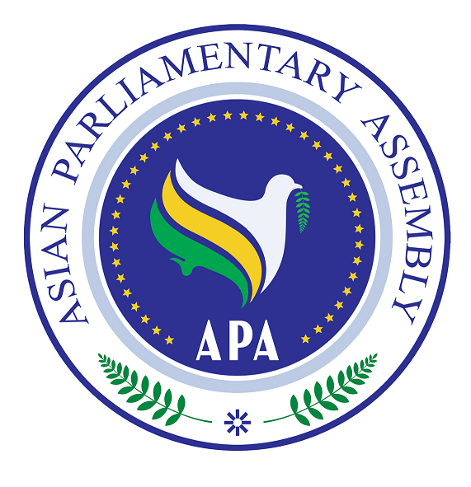
APA/Res/2010/15
30 November, 2010
Resolution on

Ramification of International Financial Crisis for the
Economies of the Countries of APA Member Parliaments

We, the Members of the Asian Parliamentary Assembly,

- Recalling Resolution on the Ramification of International Financial Crisis for the Economies of the Countries of APA Member Parliaments, APA/Res/2009/05, in Bandung dated 11 December 2009; Resolution on the Ramification of International Financial Crisis for the Economies of the Countries of APA Member Parliaments, APA/Res/2008/05, in Jakarta dated 29 November 2008;
- Concerned that the failure to address the risks which could cause the global economy enter into a double-dip recession;

- Stressing the need to ensure the just distribution of welfare through more government spending on programs aimed for the needy population which effectively help speeding the economic recovery and reduce the suffering the low income people;
- Calling upon Asian Parliaments to exercise more control on inflation as a policy priority for their governments;
- Realizing that the instability of international security and peace could cause global economic and financial crisis;

- Expressing concern about the lack of re-orientation of policies needed for rebalancing on the agenda of the major economies or the international community at large;

- Reaffirming the important role of trade and that its promotion can contribute to recovery in the world economy;

- Expressing further concern about the disconnection between the financial markets and the real economy which threatens creating new bubbles in the world economy;

- Recognizing the necessity to effectively reform the global financial architecture so
as to achieve a more balanced world economic and financial order;

- Expressing concern about the continuous negative repercussions of the ongoing crisis on the economies of the Asian countries;

- Gravely concerned about the duration of international economic recession which has had devastating consequences on Asian economies;

- Reaffirming the important role that the Asian Parliaments can play in managing and preventing further expansion of the current financial crisis;

- Considering decrease in the investments of multilateral financial institutions in the Asian countries, which, in turn, has left negative impact on their productive capacity, employment, export, and foreign exchange potentials;

- Supporting the deliberations at the UN, IMF, WTO, UNCTAD, . . . and their recommendations towards ameliorating the global financial crisis and redressing the situation;

- Appreciating the measures that have already been taken by Asian Parliaments and governments to contain the negative impact of the current crisis on their economies, and expecting them to take further steps to stimulate their respective economies;
We, therefore;
- Call upon the Asian Parliaments to extend the stimulus measures to prevent
further financial sector fallout;

- Urge the Asian states to take into serious account the risk of widening global macroeconomic imbalances which may cause a new wave of financial instability;

- Urge Asian Parliaments to re-examine the efficiency of the framework of national regulatory bodies, with a view to preventing future instability in Asian markets;

- Urge Asian Parliaments to collectively address the crisis including the establishment of a new global financial architecture and define its elements;

- Call upon APA Member Parliaments to support humanitarian mission to respond to crises in every region and lift economic blockade which jeopardize the lives of human being such as those in Gaza;

- Urge Member Parliaments to make major contributions to maintaining the stability of international economic and trade activities through preserving global security and peace;

- Decide to promote respect for international law and standards by APA Parliaments on the transparency of financial markets to ensure the clarity of financial transactions;

- Call on all APA Member Parliaments, within the context of national responses to the crisis, to accelerate their collective recovery from the crisis through adoption of appropriate legislations, improved transparency, combating and eradicating corruption, promoting democracy and a renewed recommitment to good governance;

- Urge all Asian Parliaments to adopt more effective regulations for all economic actors, including financial institutions, credit rating agencies, audit firms, and the principals in the shadow financial system;

- Urge APA Member Parliaments to develop a joint and comprehensive strategy setting out the response of the system in its multiple dimensions, globally, regionally and nationally;

- Call upon APA Member Parliaments to provide expertise to the Secretary-General to establish a Panel of Experts to conduct a comprehensive study and offer independent advice to the Sub-Committee on issues that itshall deem relevant to the whole trend of Global Financial Crisis;

- Call for the completion of a truly development-oriented trade round, to create an international trade regime which promotes growth in the developing countries, taking into account that in all trade negotiations, the long recognized principle of special and differential treatment of developing countries be preserved;

- Call upon the Asian Parliaments to closely examine the economies of several Developing and Emerging Economies (DEEs) in Asia that have structural external deficits and are hence dependent on capital inflows to sustain acceptable growth;

- Call for adjustment in the major economies of Asia with the aim of removing imbalances
without a return to financial bubbles and debt–driven spending;

- Call for close cooperation and coordination between Asian governments and Parliaments to control the persisting negative consequences of the current financial crisis on Asian economies; and

- Decide on the extension of the mandate of the Sub-Committee to review the development of the current financial crisis and to propose ways to control, manage and formulate exit strategy from the crisis.

